%{

Generates 100 points uniformly distributed in the unit disk

by generating a random radius(r) and angle(t) and then plotting

(r\*cos(t), r\*sin(t))

%}

rng(1); % For reproducibility

r = sqrt(rand(100,1)); % Radius

t = 2\*pi\*rand(100,1); % Angle

data1 = [r.\*cos(t), r.\*sin(t)]; % Points

% Creates 100 more points in a ring around the original set of points

r2 = sqrt(3\*rand(100,1)+1); % Radius

t2 = 2\*pi\*rand(100,1); % Angle

data2 = [r2.\*cos(t2), r2.\*sin(t2)]; % points

% Plots both sets of points and plots circles of radii 1 and 2 for comparison

figure;

plot(data1(:,1),data1(:,2),'r.','MarkerSize',15)

hold on

plot(data2(:,1),data2(:,2),'b.','MarkerSize',15)

ezpolar(@(x)1);ezpolar(@(x)2);

axis equal

hold off

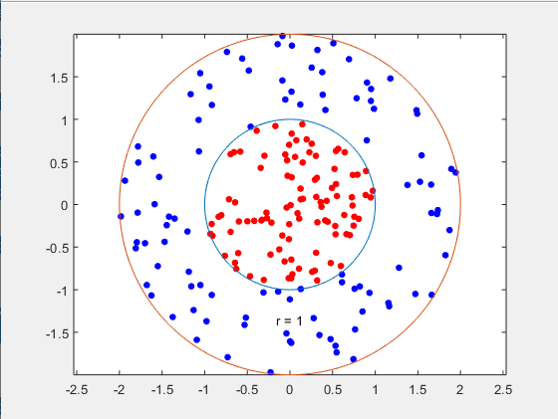

% Puts the data into one matrix and then makes a vector of the classifications

data3 = [data1;data2];

theclass = ones(200,1);

theclass(1:100) = -1;

%{

Uses KernelFunction set to 'rbf' and BoxConstraint set to Inf

to train a SVM classifier

Then plots the decision boundary of the SVM and flags the

support vectors

%}

%Train the SVM Classifier

cl = fitcsvm(data3,theclass,'KernelFunction','rbf',...

'BoxConstraint',Inf,'ClassNames',[-1,1]);

% Predict scores over the grid

d = 0.02;

[x1Grid,x2Grid] = meshgrid(min(data3(:,1)):d:max(data3(:,1)),...

min(data3(:,2)):d:max(data3(:,2)));

xGrid = [x1Grid(:),x2Grid(:)];

[~,scores] = predict(cl,xGrid);

% Plot the data and the decision boundary

figure;

h(1:2) = gscatter(data3(:,1),data3(:,2),theclass,'rb','.');

hold on

ezpolar(@(x)1);

h(3) = plot(data3(cl.IsSupportVector,1),data3(cl.IsSupportVector,2),'ko');

contour(x1Grid,x2Grid,reshape(scores(:,2),size(x1Grid)),[0 0],'k');

legend(h,{'-1','+1','Support Vectors'});

axis equal

hold off

% fitcsvm makes a classifier that is close to a circle of radius 1

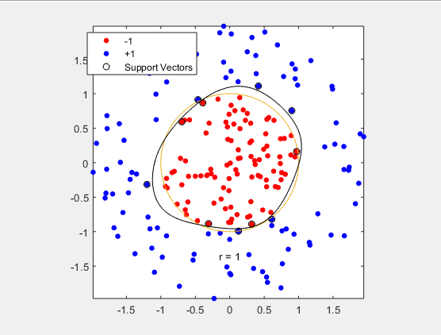

%{

Remove the BoxConstraint, allowing for a more circular line,

but also more misclassifications

%}

cl2 = fitcsvm(data3,theclass,'KernelFunction','rbf');

[~,scores2] = predict(cl2,xGrid);

figure;

h(1:2) = gscatter(data3(:,1),data3(:,2),theclass,'rb','.');

hold on

ezpolar(@(x)1);

h(3) = plot(data3(cl2.IsSupportVector,1),data3(cl2.IsSupportVector,2),'ko');

contour(x1Grid,x2Grid,reshape(scores2(:,2),size(x1Grid)),[0 0],'k');

legend(h,{'-1','+1','Support Vectors'});

axis equal

hold off

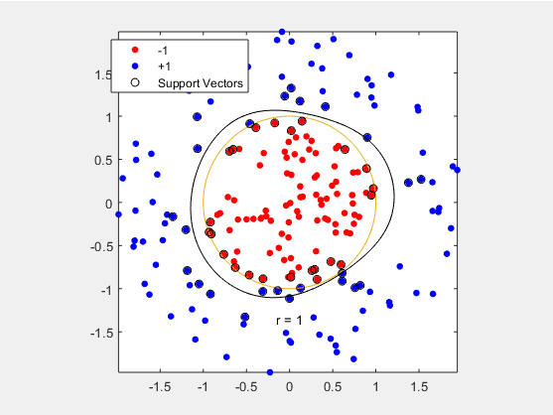

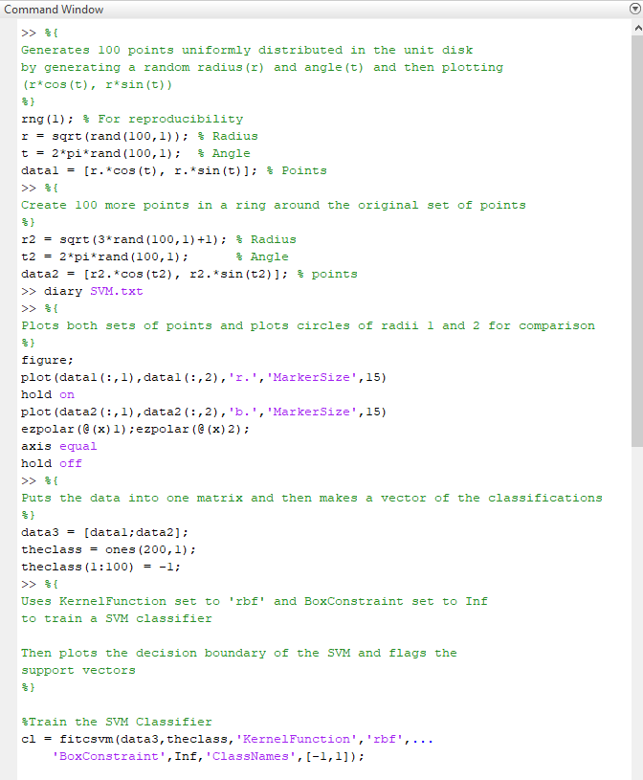

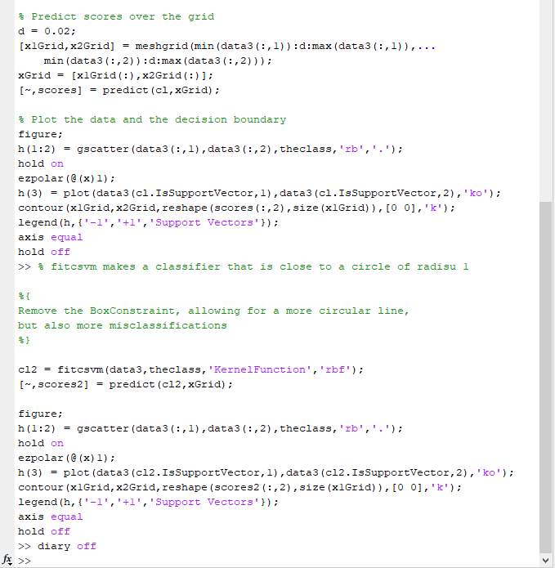

Example From:

https://www.mathworks.com/help/stats/support-vector-machines-for-binary-classification.html#bsr5oqx